Name : Shubham Sapkal

Roll No. : 2012118

Subject : KR AI ML Dl

Class : SYMCA

Assignment : Assignment 03

# Dummy variables

## Import the relevant libraries

import numpy as np

import pandas as pd

import statsmodels.api as sm

import matplotlib.pyplot as plt

import seaborn as sns

sns.set()

## Load the data

raw_data = pd.read_csv("1.03.+Dummies.csv")

raw_data

SAT GPA Attendance

0 1714 2.40 No

1 1664 2.52 No

2 1760 2.54 No

3 1685 2.74 No

4 1693 2.83 No

... ... ... ...

79 1936 3.71 Yes

80 1810 3.71 Yes

81 1987 3.73 No

82 1962 3.76 Yes

83 2050 3.81 Yes

## Map the data

data = raw_data.copy()

data['Attendance'] = data['Attendance'].map({'Yes':1,'No': 0})

data

SAT GPA Attendance

0 1714 2.40 0

1 1664 2.52 0

2 1760 2.54 0

3 1685 2.74 0

4 1693 2.83 0

... ... ... ...

79 1936 3.71 1

80 1810 3.71 1

81 1987 3.73 0

82 1962 3.76 1

83 2050 3.81 1

data.describe()

SAT GPA Attendance

count 84.000000 84.000000 84.000000

mean 1845.273810 3.330238 0.464286

std 104.530661 0.271617 0.501718

min 1634.000000 2.400000 0.000000

25% 1772.000000 3.190000 0.000000

50% 1846.000000 3.380000 0.000000

75% 1934.000000 3.502500 1.000000

max 2050.000000 3.810000 1.000000

## Regression

y = data['GPA']

x1 = data[['SAT','Attendance']]

x = sm.add_constant(x1)

results = sm.OLS(y,x).fit()

results.summary()

OLS Regression Results

Dep. Variable: GPA R-squared: 0.565

Model: OLS Adj. R-squared: 0.555

Method: Least Squares F-statistic: 52.70

Date: Sat, 29 Jan 2022 Prob (F-statistic): 2.19e-15

Time: 21:35:03 Log-Likelihood: 25.798

No. Observations: 84 AIC: -45.60

Df Residuals: 81 BIC: -38.30

Df Model: 2

Covariance Type: nonrobust

coef std err t P>|t| [0.025 0.975]

const 0.6439 0.358 1.797 0.076 -0.069 1.357

SAT 0.0014 0.000 7.141 0.000 0.001 0.002

Attendance 0.2226 0.041 5.451 0.000 0.141 0.304

Omnibus: 19.560 Durbin-Watson: 1.009

Prob(Omnibus): 0.000 Jarque-Bera (JB): 27.189

Skew: -1.028 Prob(JB): 1.25e-06

Kurtosis: 4.881 Cond. No. 3.35e+04

Notes:

[1] Standard Errors assume that the covariance matrix of the errors is correctly specified.

[2] The condition number is large, 3.35e+04. This might indicate that there are

strong multicollinearity or other numerical problems.

## Plot the regression line(s) on the scatter plot

plt.scatter(data['SAT'],y)

yhat_no = 0.6439 + 0.0014*data['SAT']

yhat_yes = 0.2226 + 0.0014*data['SAT']

fig = plt.plot(data['SAT'],yhat_no, lw=2, c='#006837')

fig = plt.plot(data['SAT'],yhat_yes, lw=2, c='#a50026')

plt.xlabel('SAT', fontsize = 20)

plt.ylabel('GPA', fontsize = 20)

plt.show()

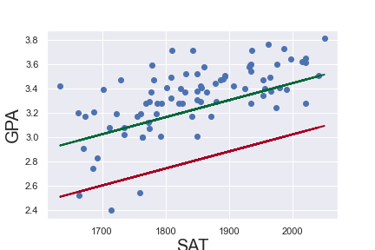

## Plot the regression line(s) on the scatter plot and colour the data points

plt.scatter(data['SAT'],y,c=data['Attendance'],cmap='RdYlGn_r')

yhat_no = 0.6439 + 0.0014*data['SAT']

yhat_yes = 0.2226 + 0.0014*data['SAT']

fig = plt.plot(data['SAT'],yhat_no, lw=2, c='#006837')

fig = plt.plot(data['SAT'],yhat_yes, lw=2, c='#a50026')

plt.xlabel('SAT', fontsize = 20)

plt.ylabel('GPA', fontsize = 20)

plt.show()

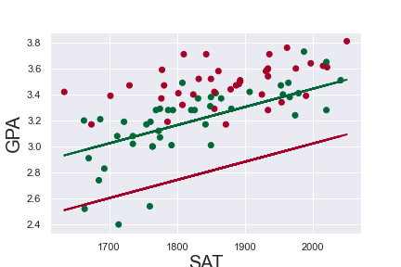

## Add the original regression line for comparison

plt.scatter(data['SAT'],data['GPA'], c=data['Attendance'],cmap='RdYlGn_r')

yhat_no = 0.6439 + 0.0014*data['SAT']

yhat_yes =0.2226 + 0.0014*data['SAT']

yhat = 0.0017*data['SAT'] + 0.275

fig = plt.plot(data['SAT'],yhat_no, lw=2, c='#006837', label ='regression line1')

fig = plt.plot(data['SAT'],yhat_yes, lw=2, c='#a50026', label ='regression line2')

fig = plt.plot(data['SAT'],yhat, lw=3, c='#4C72B0', label ='regression line')

plt.xlabel('SAT', fontsize = 20)

plt.ylabel('GPA', fontsize = 20)

plt.show()

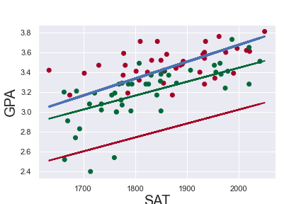

# How to make predictions based on the regressions we create

X

const SAT Attendance

0 1.0 1714 0

1 1.0 1664 0

2 1.0 1760 0

3 1.0 1685 0

4 1.0 1693 0

... ... ... ...

79 1.0 1936 1

80 1.0 1810 1

81 1.0 1987 0

82 1.0 1962 1

83 1.0 2050 1

84 rows × 3 columns

new_data = pd.DataFrame({'const': 1,'SAT': [1540, 1840], 'Attendance': [0, 1]})

new_data = new_data[['const','SAT','Attendance']]

new_data

const SAT Attendance

0 1 1540 0

1 1 1840 1

new_data.rename(index={0: 'Ram',1:'Balram'})

const SAT Attendance

Ram 1 1540 0

Balram 1 1840 1

predictions = results.predict(new_data)

predictions

0 2.799545

1 3.442129

dtype: float64

predictionsdf = pd.DataFrame({'Predictions':predictions})

joined = new_data.join(predictionsdf)

joined.rename(index={0: 'Ram',1:'Balram'})

const SAT Attendance Predictions

Ram 1 1540 0 2.799545

Balram 1 1840 1 3.442129